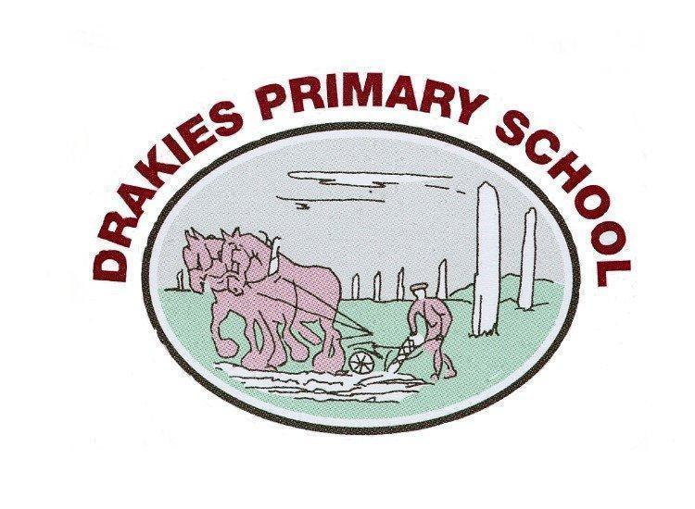


Please ask for: Scott Callander Telephone No: 01463 236032
E-mail: drakies.primary@highland.gov.uk
Date: January 2020

Dear Parents/Carers,

Happy New Year! I hope everyone had a relaxing Christmas break and that you are settling into the new term nicely. Here is a brief overview of what term 3 has in store for P1.

Phonics
We will continue to introduce two new sounds each week on Mondays and Wednesdays until all initial sounds have been introduced. We will also be focussing on blending to help us read full words. If you feel your child is not confident reading cvc words, you can continue to use the sound cards in homework bags for word building practice.
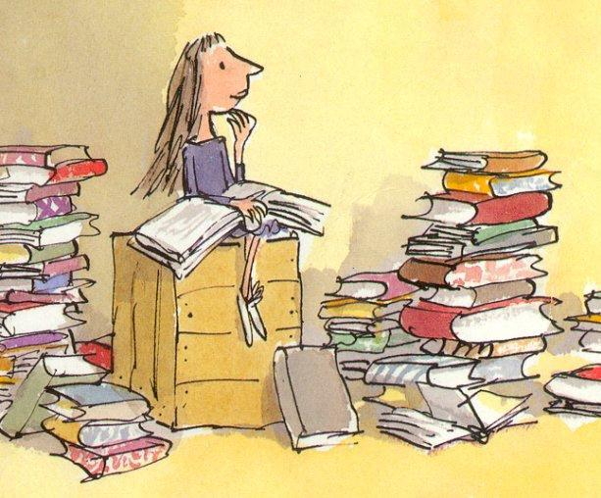
Reading
Reading will continue the same as last term with new books being introduced on Mondays and allocated to the children’s BugClub accounts. Please engage with this as much as you can at home. We are really enjoying reading these books in class and hope you are at home too.

Numeracy and Maths
The children will be introduced to money at the start of this term. We will focus on recognising different coins and making amounts. This will lead us on to multiplication when the children will learn to count in 2s, 5s and 10s and begin making sets of equal groups. Alongside this we will continue our number knowledge; counting forwards and backwards and recognising, ordering and sequencing numbers as well as addition and subtraction.

PE Kit
Please ensure your child brings a PE kit for use on Tuesdays and Wednesdays. PE kits can be kept at school in case of any extra sessions and can be taken home for washing every couple of weeks.

Topic
This term we will be looking at a variety of Science based mini topics. These will include Space, The Human Body and Electricity. We are really looking forward to all the learning experiences in Literacy, Numeracy, Science and Expressive Arts related to this topic. We will also be looking at Chinese New Year at the end of January and for RME will be looking at a selection of Bible Stories including The Good Samaritan, Noah’s Ark and Jonah and the Whale.

Homework
Phonics homework will continue as it was in term 1 and 2 with new sounds being added as they are introduced in class on Mondays and Wednesdays. Reading will also continue as it was so please engage with your child’s reading books allocated on BugClub.
There will be no new Numeracy homework this term. However, your child may benefit from extra practise the activities from terms 1 and 2. If you require another copy of these activities please just ask. There may also be extra topic related homework challenges given out throughout the term.
Remember that homework should be an opportunity for you to spend time with your child, show an interest in what they are learning at school and enjoy seeing the progress they are making. If you find that homework is becoming a stress or is making your child upset, please leave it and try again another time.

Dates for your diary:

Wednesday 12th February - Open Afternoon
Monday 17th and Tuesday 18th February - Holiday
Wednesday 19th - In-service Day (school closed to pupils)

If you have any concerns or queries please don’t hesitate to come and speak to me or send an email to Alison.Graham3@highland.gov.uk.

Please check our Blog and Twitter for updates.
Blog: https://drakiesprimaryone2019.school.blog/
Twitter: @MissGraham_P1

Thank you for your continued support,
Miss A Graham (P1 Class Teacher)

